**Question 1**

Let us start by declaring our variables: A = {1, 2, 3, 4, 5, 6, 7, 8, 9, 10, 11, 12, 13, 14, 15} and:

p – “n is an odd number” => p = {1, 3, 5, 7, 9, 11, 13, 15}

q – “n is a prime number” => q = {2, 3, 5, 7, 11, 13}

r – “n is less than 8” => r = {1, 2, 3, 4, 5, 6, 7}

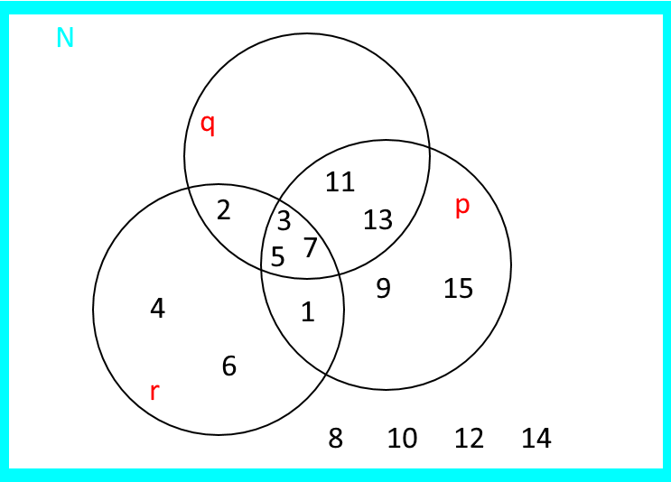

1. p ^ q = {3, 5, 7, 11, 13}

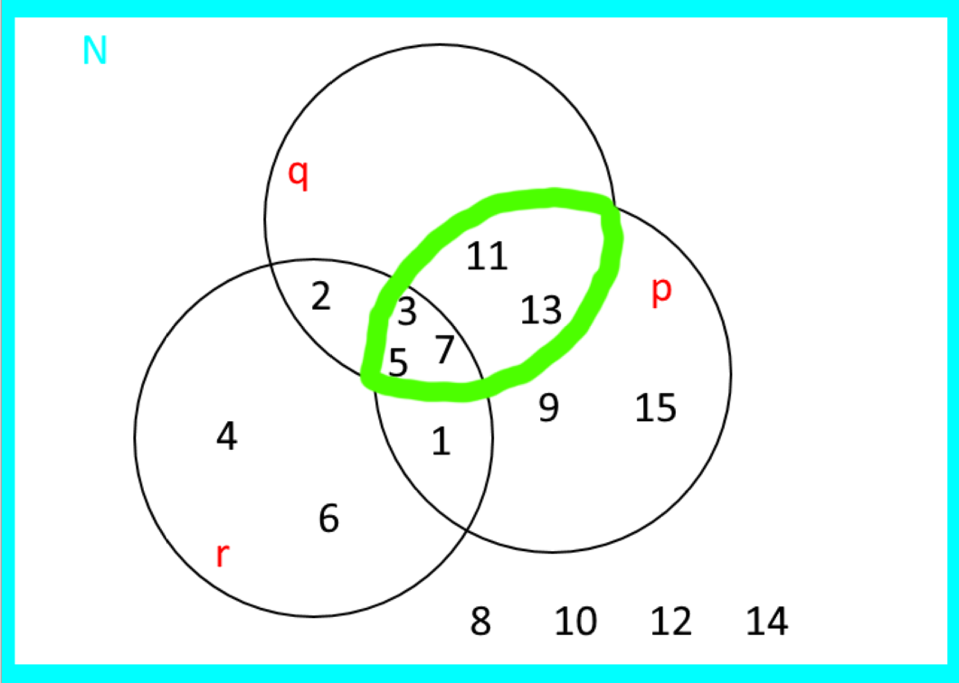

p Ꚛ q = {1, 2, 9, 15}

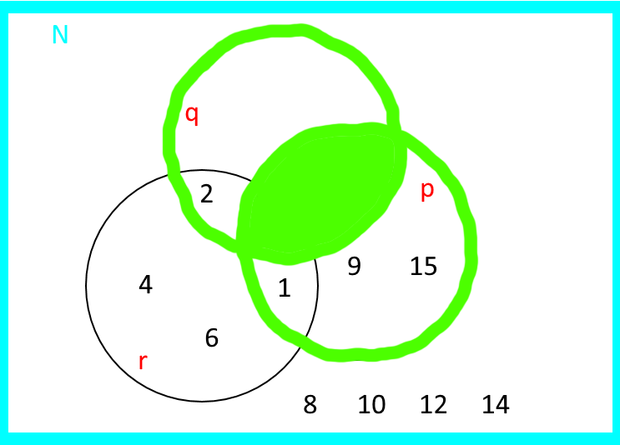

p -> q = {2, 3, 4, 5, 6, 7, 8, 10, 11, 12, 13, 14}

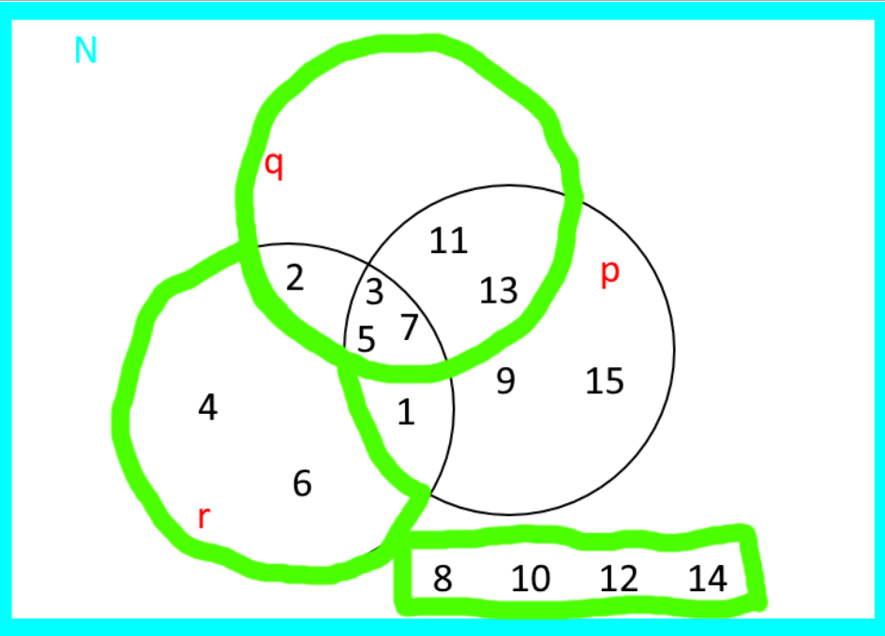

r -> q = {2, 3, 5, 7, 8, 9, 10, 11, 12, 13, 14, 15}

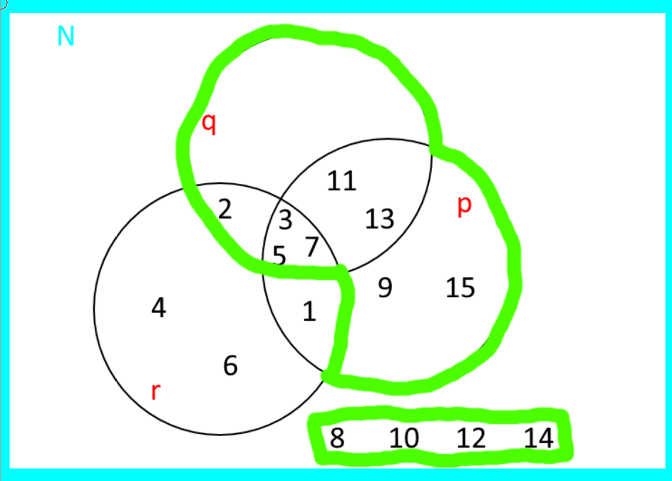

1. “n is neither odd nor is a prime” = ¬(p v q);

“if n is odd and less than 8 than n is a prime number” = ( p ^ r ) -> q;

“n is a prime number only if n is odd” = (q -> p);

“n is a prime number if n is odd” = (p -> q);

1. Contrapositive of the “q -> p” = (¬p -> ¬q);

In words it can mean: “if n is even then then it is not a prime number”.

**Question 2**

(p -> q) = ¬p v q => (p -> q) ⋀ p => (¬p v q) ⋀ p => (¬p ⋀ p) v (q ⋀ p) => F v (q ⋀ p) => (q ⋀ p) => (q ⋀ p) = (p ⋀ q)

|  |  |  |  |  |
| --- | --- | --- | --- | --- |
| p | q | p -> q | ¬p | ¬p v q |
| 1 | 1 | 1 | 0 | 1 |
| 1 | 0 | 0 | 0 | 0 |
| 0 | 1 | 1 | 1 | 1 |
| 0 | 0 | 1 | 1 | 1 |